Elise Tomlinson – Artist  www.elisetomlinson.com  Commissions Welcomed  (907) 364-3694   | Elise Tomlinson – Artist  www.elisetomlinson.com  Commissions Welcomed  (907) 364-3694  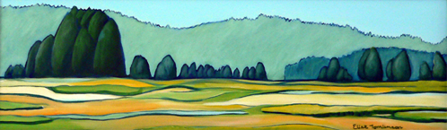
Elise Tomlinson – Artist www.elisetomlinson.com  Commissions Welcomed  (907) 364-3694  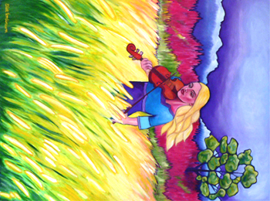 | Elise Tomlinson – Artist  www.elisetomlinson.com  Commissions Welcomed  (907) 364-3694  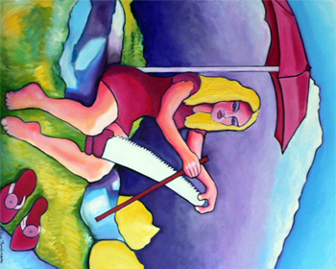
Elise Tomlinson – Artist  www.elisetomlinson.com  Commissions Welcomed  (907) 364-3694  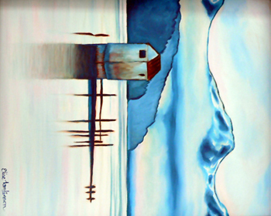 | Elise Tomlinson – Artist  www.elisetomlinson.com  Commissions Welcomed  (907) 364-3694  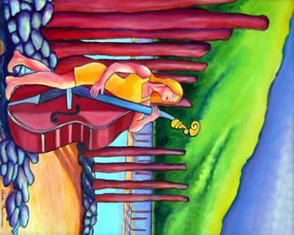
Elise Tomlinson – Artist  www.elisetomlinson.com  Commissions Welcomed  (907) 364-3694  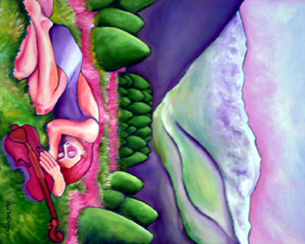 | Elise Tomlinson – Artist  www.elisetomlinson.com  Commissions Welcomed  (907) 364-3694  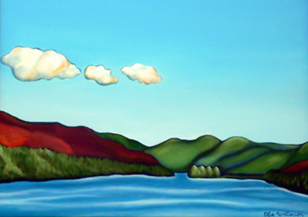
Elise Tomlinson – Artist  www.elisetomlinson.com  Commissions Welcomed  (907) 364-3694   | Elise Tomlinson – Artist  www.elisetomlinson.com  Commissions Welcomed  (907) 364-3694  

